Step-by-Step Guide to Mixing Colour

1. Hue 2. Bias 3. Value 4. Chroma
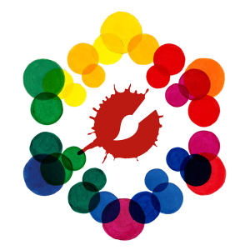
The most frequently asked questions I receive are about mixing colours. People often struggle to match the colour they are seeing or complain that their colours are getting muddy.
I will address the mud issue first and then show you a very simple 4-step guide to identify and match any colour under the sun.

Mud
Muddy colours come from three culprits…
- Bad value exchange. Having middle of the road values and having the wrong value for the plane you are painting.
- Dirty equipment. Begrimed brushes, a messy palette including contaminated whites (oil and acrylic) or polluted thinner/water.
- Having too many colours on your palette and not knowing what they will do. It’s amazing what you can do with less colours. Anders Zorn quite often used only 4 colours to paint his masterpieces. See the Bonus Tip below.
Keep this in mind because no amount of colour theory can fix this problem. Most of you know me as a very messy painter, but I assure you - even though I myself may be a mess, I keep my equipment (brushes, thinner and palette) clean.

4 Steps to Colour Mixing
There are 4 main steps to matching any colour and if you use them in the right order you will get cleaner and more accurate results every time.
- Hue
- Bias
- Value
- Chroma
This is the correct order! If you put chroma before value your colours will turn chalky.
The most important thing to remember before we begin mixing colours is that there are only 6 colours on your palette. I don’t care how many tubes you squeezed out, they all fall into one of the following six colours:
Primary: Red, Yellow, Blue. Secondary: Orange, Green, Purple.
That’s it! Knowing that, we can now begin the process of identifying the colour you want.

1. Hue

Identify the colour you want to make.
Identifying the right hue (colour) is the first step in the process. It seems simple, but this is where most people falter. You must carefully observe and describe (in words) the colour you are trying to make.
The problem occurs when you use vague terms for your colour…
For example: Brown is not a good way to describe colour. Burnt Sienna is brown, and so is Raw Umber. BUT! Burnt Sienna is an orange and Raw Umber is a green!
Therefore, saying “brown” is of no use until you add a primary or secondary name to it. By adding a primary or secondary colour word to your description lets you know what colour your dealing with.
Another Example: Pink is not a colour. It is a word to describe a red with white added to it. Fuchsia, violet, magenta, grey, are all descriptive words. There is no such thing as grey! Grey is always a dull version of some colour.
So remember! When you describe your colour correctly, you will know how to mix it. Say things like...
Green Gray or Purple Gray or Blue Gray (as in a rainy New York skyline). You can say "New York Skyline Blue" to describe it but to MIX it you must actually state the colour you want to make. Blue Gray.
Some hues tread a fine line between two colours, but when you begin with a clear description, the subtlety will fall into place as you refine your mixture. It takes time to develop a sense for identifying colour correctly but with persistent effort you will begin to see colours with a finer and finer sensibility and clarity.
To review - You must first identify the colour you want to make and describe it as one of the six. After that...

2. Bias

Identify the bias in the colour you want to make.
Here is the tricky part. Once you have identified and described the colour, you must also identify its bias. Each of the six colours mentioned above has a bias (tendency). Every colour on your palette has a colour bias. Colour bias is the colour's tendency toward one end of the spectrum or the other.
Primary: Red is never just a red. It’s either a blue red (tending toward purple) or a yellow red (tending toward orange).
Secondary: Purple is never just a purple. It is a purple leaning to the red side or a purple leaning to the blue side.
By identifying the tendency of the colour you want to make helps you choose the suitable colours that you need make that mixture. Remember: The colours you’re using in your mixture and the colour you’re trying to make have tendencies. By identifying both you will have a much easier time getting the colour you’re looking for.

EXAMPLE: Mixing Purple (blue+red)
Ask yourself: Is it a blue-purple (violet), or a red-purple (magenta)?
Choose the right blue:
If it’s a blue-purple you want to pick an Ultramarine Blue because it has a red tendency, rather than a Cerulean Blue which has a green tendency. If you don’t, you will mix mud because green is the opposite of red and they will fight.
Choosing the right red:
If it’s a red-purple you want to pick a red with a blue tendency like Alizarine or Quinacridone Rose rather than an orange red like Cadmium Red Light or Naphthol Red because the orange tendency will conflict with the blue.

3. Identify the Value
Take a deep breath, the hard work is done. This step is easy.
Is the colour you want: Light, Medium or Dark?
This determines how much white or how much of the darker colour (not black) you need to use in your mixture.

4. Identify the Chroma
This final step is also easy.
Is the colour you want: Bright, Medium or Dull?
You can dull down the nature of any colour by adding it’s opposite to the mixture. If you want to dull down a purple mixture, add yellow to it. Done.
Bob’s your Uncle! You have the colour you’re looking for. All that’s left is a bit of tweaking, which by this point should be easy to identify.

Tips to remember:
- Always mix your Value before Chroma or your colour will be chalky.
- Keep your brushes clean and have lots of unsullied space on your palette to achieve accurate mixes.
- For a fresher look don’t over mix your colours on the palette, let them hit the canvas or paper just slightly under-mixed.

BONUS TIP:
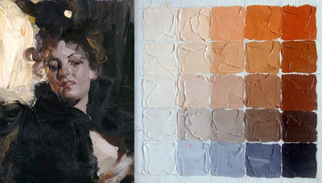Note about the limited palette of Anders Zorn.
Having too many colours on you palette and not knowing what they do is a serious obstacle for any painter. Keep it simple! It’s amazing what you can do with limited colours. Anders Zorn is famous for his limited palette and often using only 4 colours to paint his incredible masterpieces.
Andes Zorn palette (using today's equivalents) would include: Ivory Black; Titanium White; Cadmium Red Light or Naphthol Red; Yellow Ochre.
Another benefit to using a limited palette is that it brings a distinct harmony to your painting.

Keep those brushes swinging and let me know if you have any questions. It’s my job to help you be the greatest artist you can be.
Your friend in art,
Doug

