10 Lifelines To Help When Your Painting Is In Crisis.

What to do when your painting is not at it's best.
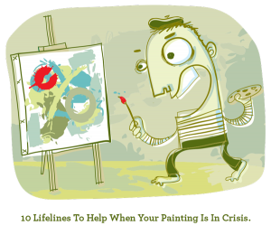
You are merrily painting along when you start to sense that things are getting a bit murky. Then, in a flash, things become very bad... Calm waters churn into choppy seas. Lights flicker, then go out. Red emergency lights flash on, spinning, while sirens sheer through the studio “awooga awooga!!” An ominous voice is heard overhead, “We have an emergency situation…abort painting…abort painting.”
This is the scenario that plays out in my head when a painting suddenly takes a nasty turn.
Holdfast my friends.
Inside every crisis is an opportunity!

1. You’ve got questions, we’ve got answers.
Remain Calm! If you ask the correct questions you will find solutions. First and foremost, ask yourself the following:
- Is this painting fixable? Is it worth the effort?
- Are the values legible or are there too many muddy passages?
- Is the drawing correct? Is the composition sound?
- Is there a good balance of grayscale design? Or does it look like a cut-out?
- Does it have enough gradations - large and small and interlocking patterns?
- Does it have an area of attention or a centre of interest?
- Maybe it needs a sense of mystery, fantasy, illusion or wonder?
- Are there too many slashes, swipes and textures?
- Are there quiet areas to contrast the visual noise?
- Does it needs one area to determine what another area will be?
2. Wipeout!
Sometimes things get too busy and need simplifying. Take a palette knife and CAREFULLY wipe out sections of the painting to get back to some sort of underpainting stage that can be built up again. With watercolour you can soak an area and blot it to get you back to an early stage (provided you're not using too many staining colours).
If it’s in the early stages of the painting, you can wipe the entire surface back and start all over again. If you’re in a bit deeper, perhaps you just need a light removal. Wipe away enough to leave a ghost of your painting to work upon. If it’s the little things that need removing, the humble Q-tip can be your new best friend.
3. Big brother is watching.
Look to your peers or mentors to offer suggestions on how to salvage your painting. Look up an artist or artists to see what their answers to a problem have been. Every good painting is a solution to a set of problems. This isn’t the time to re-invent the wheel. Somewhere out there someone has come across this problem before. At the very least, you will find an artwork to get yourself inspired.
4. Room with a view.
Looking at your work in a mirror will give you a fresh perspective. Place it on the floor (paint side up of course), and look at it upside down. The fresh view from a different location will provide much needed brain fodder.
5. B2B
Go back to the source. Remind yourself of what it was you had originally set out to achieve. Are you capturing what you originally wanted to portray? Is the painting following the sketch you set out for yourself? (Of course you did a thumbnail sketch to begin with didn’t you?) 90% of problems occur in the first 5 minutes of a painting.
6. Lab coat and goggles.
A bad painting is a good time to experiment. If your painting is getting beyond the wipe-off stage, why not let loose! Take a shot at some new process and experiment. Explore a new technique or use a new colour. Take a crack at that funky big brush you bought on sale and have been too chicken to try. Now is the time!
7. Simple Simon
If you need to start over, take some time to re-centre yourself. Take a break and walk away. If you find that you have bit off more than you can chew, get back to basics and paint a simple subject, like an apple. Just a lone apple without too many colours. This practice resets the brain, helps you refocus and remember what you are trying to achieve.
8. Run around Sue.
If your painting seems beyond repair, don’t despair. Here is Sue Contini’s patented list of “10 Ways to Save a Painting”
8.1 - Cut out smaller paintings from the big one. Look for mini compositions that can be smaller paintings.
8.2 - Is there a section to make a bookmark out of?
8.3 - Cut out pieces to create a collage painting.
8.4 - Cut some panels into Xmas ornaments and covered them in glitter. Glitter fixes everything!
8.5 - Cut the painting into strips to weave into coasters and placemats, or to wrap around baskets.
8.6 - Cut interesting sections into squares and rearrange them in a grid to turn them into book covers, wrapping paper, wine gift tags and bows.
8.7 - Make a painting apron out of a couple of duds sewn together. You can also make shoes and hand bags.
8.8 - Block print over it with a high contrast colour for a unique effect.
8.9 - Glue-gun them into little 3-d hearts for valentines day.
8.10 - Give pieces to kids to make 'imagination art', dollhouse rugs, a waterproof mat under the dog dish, Hallowe'en costumes, etc.
9. Burning at the stake.
A stack of bad paintings can make for a great burning party. Don’t miss this opportunity to get your fellow artists together and get your pagan on. Oil paintings torch rather well! Take a matt knife to the canvas first. The sound and feel of slashing canvas is morbidly gratifying.
10. Tinkerbell
Sometimes, if you simply walk away from your bad painting and go to bed, the fairies work their glittering magic and you wake up with a lovely painting. Don’t get too bent out of shape if the fairies don’t show up. It happens. One day chicken and the next day feathers.
It’s never too late to start over. Don’t get too attached to your paintings. If plein air has taught me anything, it’s not to get too attached to a painting.
Slow down, relax and take some time to analyze. It’s all about the journey, not the destination.
Happy painting!
Your friend in art,
Doug.

Painting Beyond Chaos - Simplification and Massing

How to simplify your subject to produce a better painting.
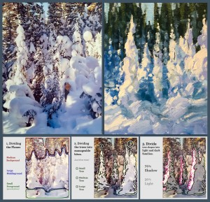
The busier the scene the easier it is to paint.
I know this sounds odd but a chaotic scene has a way of being easier to paint than something overly simple. Large empty/flat areas with little information can be hard to handle because there aren’t enough visual clues to glean ideas from.
Your subject (nature, photo reference, still-life, figure) can sometimes seem to have so much complex information that it becomes hard to decide what it is you want to paint, but at least there is something to work with. It’s just a matter of learning to read beyond the chaos and find the story that lies within. Here is how:

The tendency to start painting every detail right from the get go will produce a painting that is busy and confusing. The answer is to read between the lines and simplify. But how does one do that?
My process is to begin by breaking the picture down into more manageable bites. Grouping similar masses will help you decode the structure of what it is you’re trying to paint.
Massing Groups:
- Similar shapes
- Similar values
- Similar colours
- Similar temperatures
Start by breaking it down into some simple large shapes. Try not to have more than 5 major shapes in a painting. Any more and it gets confusing. 3-5 makes it easy for you to paint and for the viewer to understand.
Example:
This photo of winter trees is just oozing with information.
Let's break it down into manageable chunks:
1. Divide the image into 3 shapes, making them different in size to ensure an engaging composition.
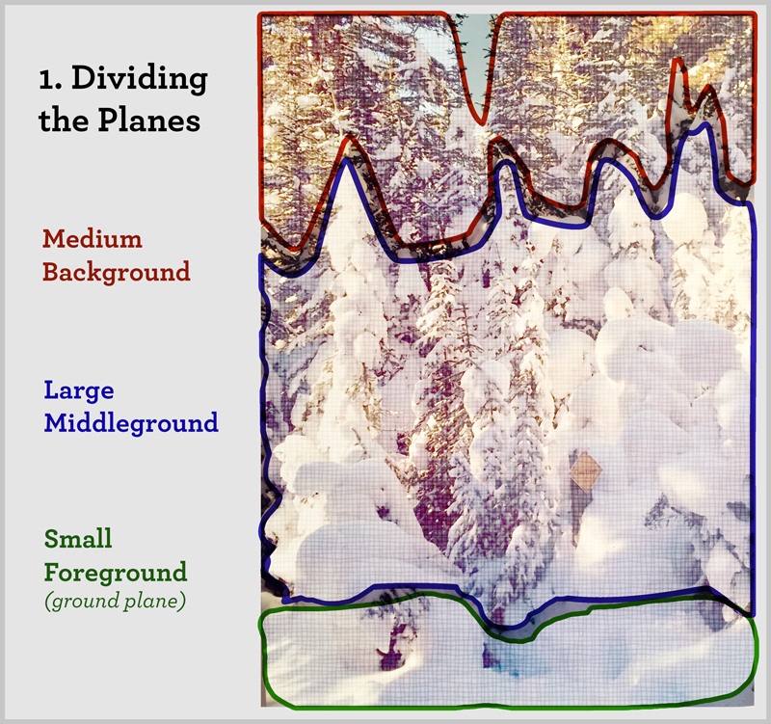
2. Divide those 3 shapes into smaller shapes. Doing so lets me get to the heart of the picture.
Note: You do not need to draw every tree and branch! You only need to place a few choice trees and make sure you have identifiable tree bits at the tops. Placing the rest in a similar value block will make it read as trees.
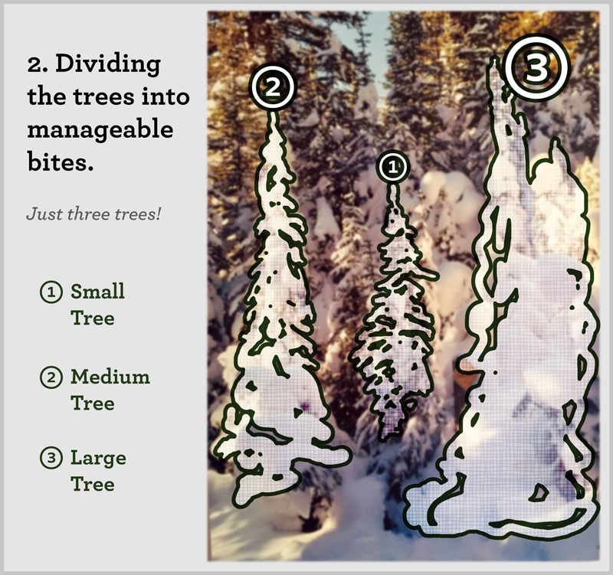
3. Divide the tree chassis into light and dark families.
Here is where I get to use my artistic savvy and amp up the composition even further. By splitting the light side and dark side into unequal parts I will get one to dominate over the other and also make it easier to paint.
I also divide the light side and the dark side into warm and cool, further establishing the look of the painting.
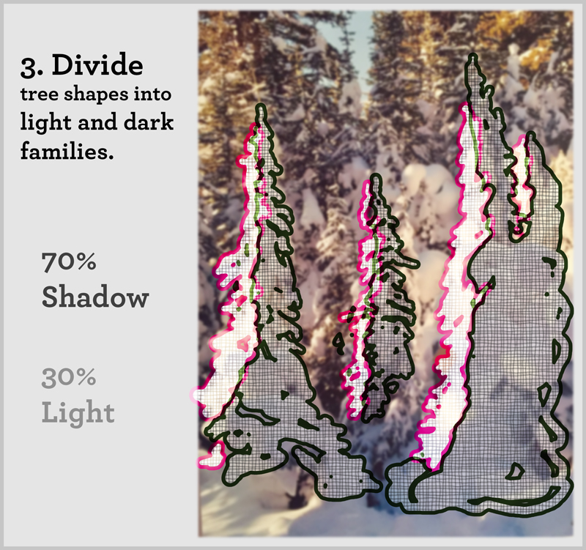
Dividing the scene into manageable morsels will help you handle the paint application with more confidence and your painting will look looser and more accurate.
Your friend in art,
Doug
- 
 