7 Ways To Give Your Painting Dimension

Value, Temperature, Chroma, Perspective, Texture...
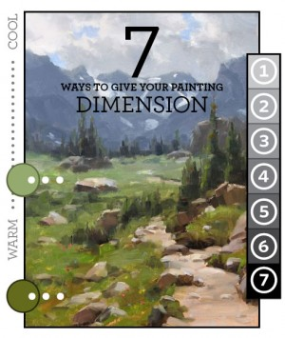
It is important to be able to translate what you see in three dimensions onto a two-dimensional surface and to convincingly evoke the sense of depth and space. Learning how to create different spatial effects can make your paintings stronger and more interesting. You don’t want your landscape painting to look flat. Use the following technique to create paintings that appear to have distance and depth and make your landscape or still-life more convincing.

You can use one or a combination of these techniques to lead the viewer's eye into the scene.

- Value
Items that are nearer on the picture plane have a higher degree of value range (the lights and dark difference). As the distance recedes the values will get closer and more narrow. Trees in the front of the picture may use a value range from 2 to 8 but trees nearer the horizon line , well into the picture plane, may have a range of only 5 to 7. Objects like rocks and trees or clouds get closer in values as they recede having less and less contrast.
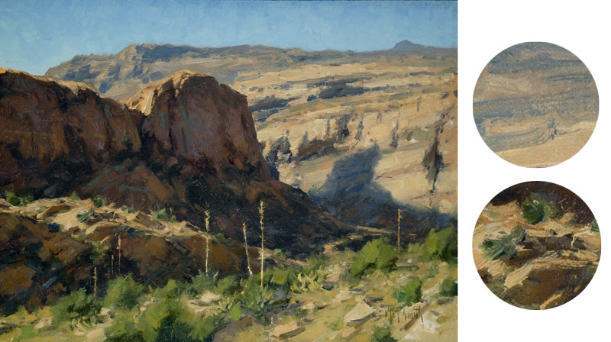
Painting by Matt Smith

- Temperature
Warm tones come forward and cool tones recede. Colours cool significantly as they move back into the picture plane. Notice how all the warms are near the front of this David Santillanes painting.
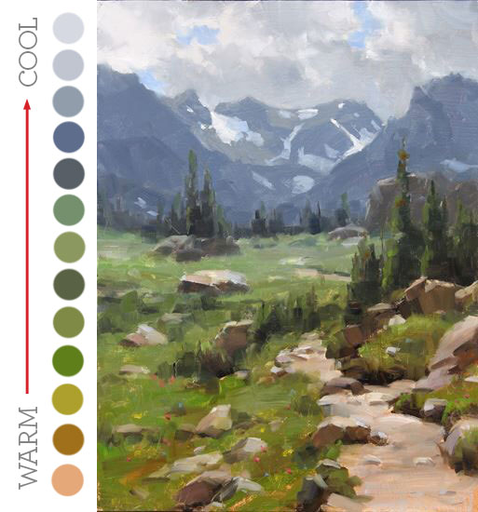

- Chroma
Bright colours come forward and dull colours recede. If you want something to look like it’s in the distance, not only do you need to cool it off but you must also make it duller.
In this Jill Carver (WEBSITE) painting all the brightest colours are in the front of the canvas and as you recede the colours get much more muted. This is a good reason to have a puddle of grey always working for you on your palette.
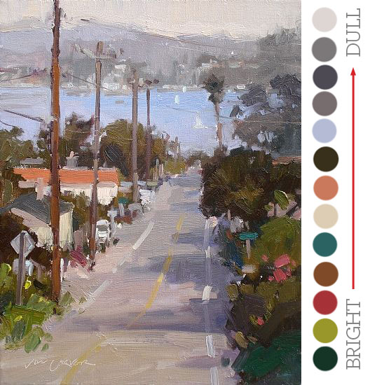

- Linear Perspective
The more vertical a line is, the more it comes forward. The more horizontal a line is, the more it tends to recede. Angles get more acute as they near the bottom of the canvas and get more horizontal as they recede into the plane of the picture.
The subtle “s”curve is another way to use this method.
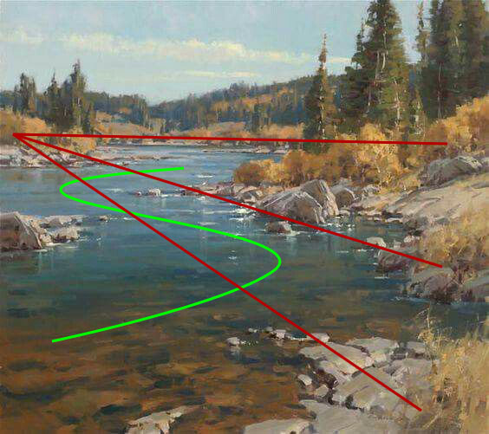
Painting by Scott Christensen

- The Big 3 Shape Changers
Overlapping shapes, size and layering are 3 other methods that can be used to achieve depth. These can be used alone or in conjunction with each other in placement.
Objects should look bigger as they get near to you and smaller as they recede.
Overlapping objects will air in recession as well. Proper placement of objects helps.
Notice how cloud “c” seems larger than cloud “a”. The optical illusion here is because things closer to eye level should be smaller in size. By combining size and placement you get a stronger sense of recession.
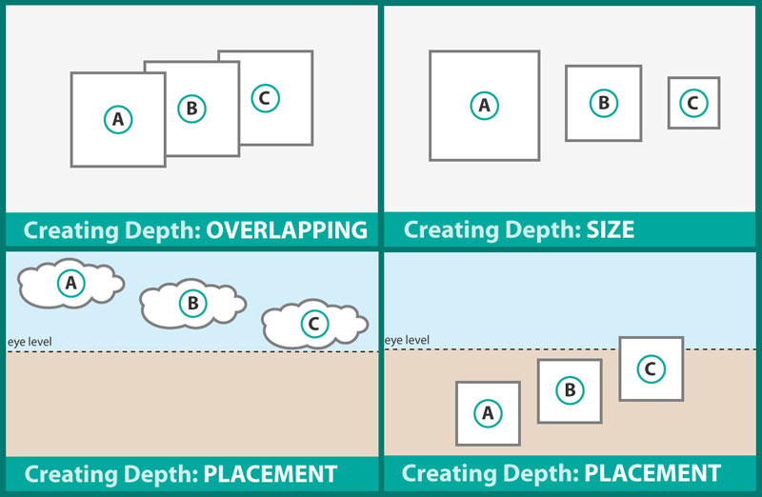

- Foreground Interest
Sticking some big stuff in the foreground of the painting can do wonders for creating the illusion of distance. Have a look as this John Carlson painting (Yes - the same John Carlson that wrote the book you should re-read. You do have Carlson’s Guide to Landscape Painting don’t you?)
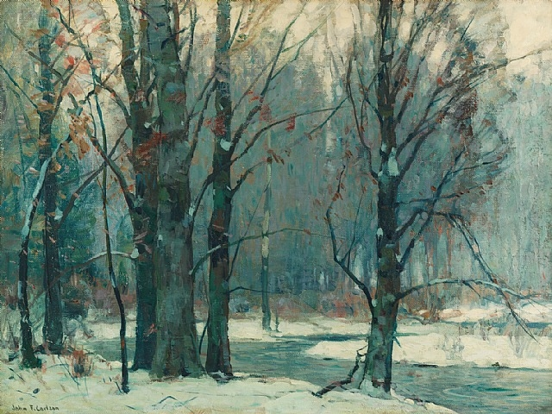

- Detail and Texture
Objects have more detail the closer they are and less as they recede. Also, thick paint tends to come foreword and thin paint tends to recede. This all needs to be held into context if you’re using it to enhance your centre of interest.

Although it”s hard to tell from a photograph, this Ted Goerschner painting has all the thicker paint applied to the tea pot and the fruit in the front of the painting. The flowers and vase have a thinner application.
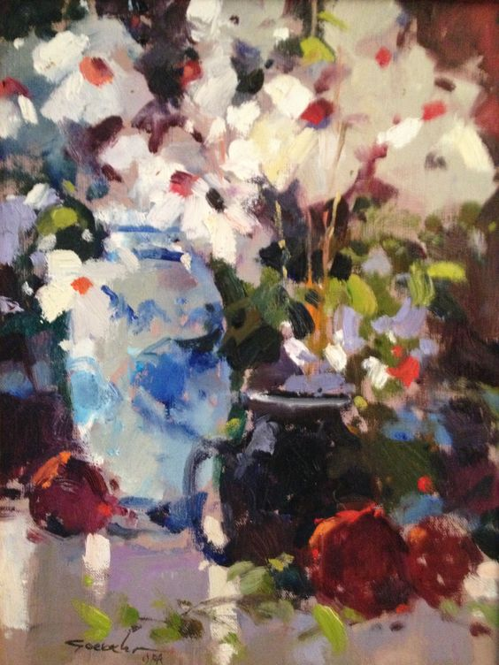
In this world class painting by some unknown dude from Calgary, he has used a combination of techniques.
- Cooler colours in the back and warmer colours in the front.
- A slight “s” curve to lead you in.
- Overlapping trees.

Again, hard to tell from a photograph, but the paint in the snow has been applied with a heavier application, while the trees are thinner and the hill in the back is thinner yet. (I know, because I know the guy who painted it.)
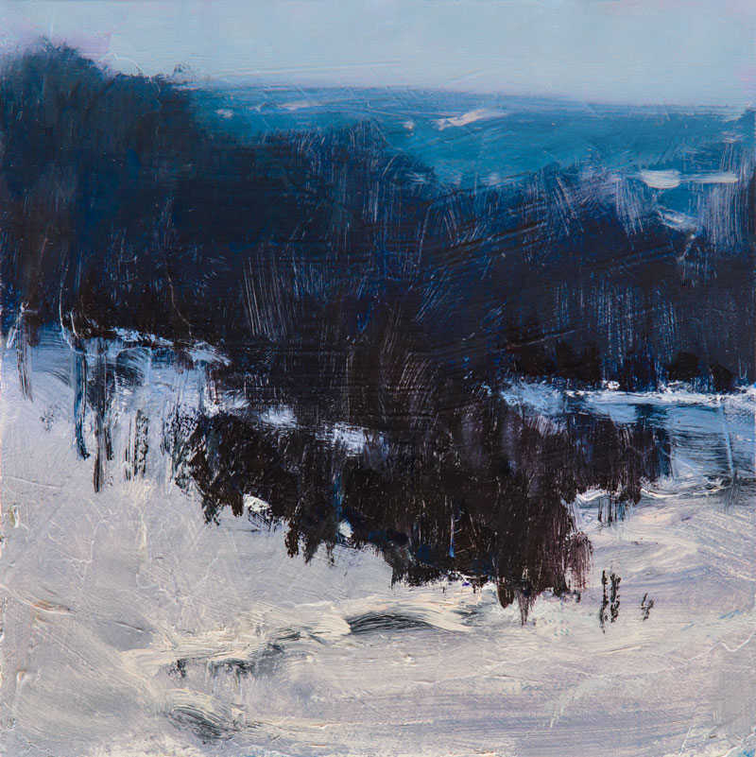
Thats all for now kiddies. Keep those brushes swinging!
Your friend in art,
Doug.

