Identifying and Painting Tricky Values Accurately

Light colours in shadow & dark colours in light • Art Lesson by Doug Swinton
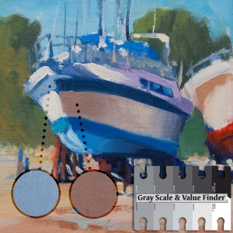

This art lesson deals with a simple idea which is often under-utilized or overlooked by most artists. It explains how to accurately recognize and render light values living in the shadow family and dark values living in the light family...
Before you even begin, make sure you have a good source to paint from. Without good lights and shadows in your reference the painting will end up looking flat. Now try to separate your scene into the light and shadow families. Accurate separation of lights and darks makes for a more pleasing painting.
Here is where the lesson begins: Notice that the value of any colour, from the darkest to the lightest can live in either the shadow or the light section of the painting. In other words, you can have a light value living in the shadow family and a dark value living in the light family.
These reference photos illustrate the extremes in value separation. Look carefully… Just because something is black does not mean it lives only in the dark family.
Let’s observe this on the boat “Lady D”. Notice the black band painted around the bow of the boat. Look at it’s value on the side lit by the sun. Now notice that the white on the base of the boat in the shade - it lives in the shadow family and is actually darker than the black that is in the light family. The white is darker than the black!
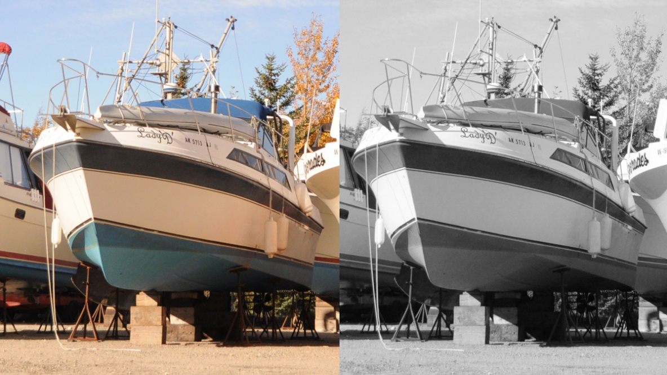
Let’s pause here and let that sink in…
Now let’s look at another example, on Mirabell the cow. Look carefully. The dark patch of her hide that is in the sunlight (even though it’s black) is lighter than the white that is in shade!
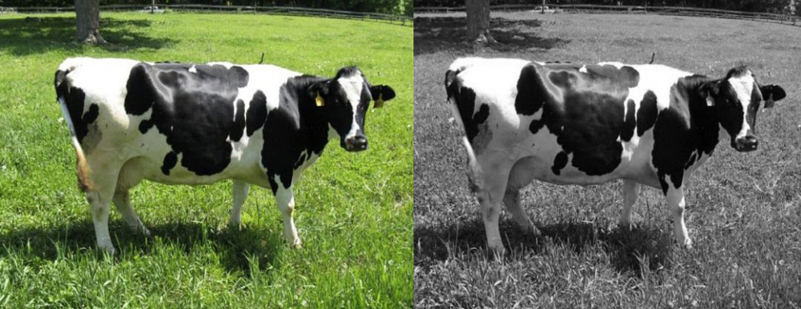
Keeping your values straight by continually comparing and actually seeing them for what they really are and not what you think they are is a concept the can raise your paintings to new heights.
Don’t forget these couple of aids that can help in the assessment of value.
- The Red Value Finder takes away colour and helps you see the values more clearly.
- And this little tool - Gray Scale & Value Finder - which should be in every paint box from here to Poughkeepsie.
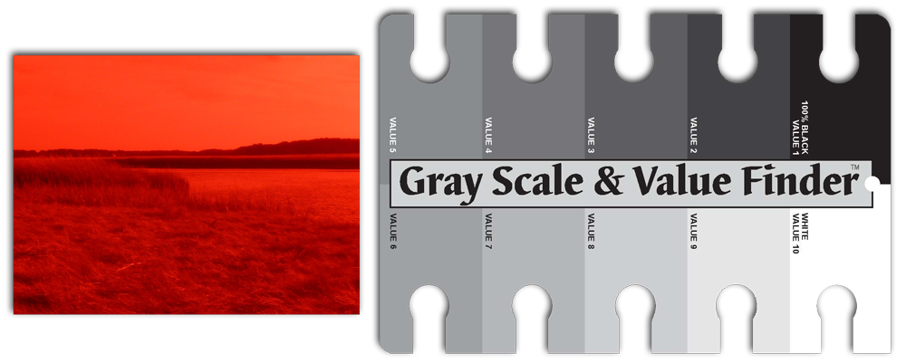
Once you have found the correct value, match it to the colour you want to paint. That’s a lesson for another day.
Hope this helps. Keep those brushes clean! Class dismissed.
Your friend in art,
Doug

